Budget

Contents

Budgets Overview 3
How Budgets Work 3
Budget Concepts 3
Required IAM Policy 4
Creating Budget using ORM stack 5

Budgets Overview
Use budgets to set soft limits on your Oracle Cloud Infrastructure spending. You can set alerts on your budget to let you know when you might exceed your budget, and you can view all your budgets and spending from one single place in the Console.
For example, if you’re running a single instance and want to monitor spending on it, you can create a budget on the compartment in which the instance is running. If you don’t have any sub compartments in your tenancy, create a budget instead against the root compartment.

How Budgets Work
Budgets are set on cost-tracking tags or on compartments (including the root compartment) to track all spending in that cost-tracking tag or for that compartment and its children.
All budgets’ alerts are evaluated every hour in most regions, and every four hours in IAD. To see the last time that a budget was evaluated, open the details for a budget. You will see fields that show the current spend, the forecast and the "Spent in period" field that shows you the time over which the budget was evaluated. When a budget alert fires, the email recipients configured in the budget alert receive an email.

Budget Concepts
The following concepts are essential to working with budgets:
BUDGET
A monthly threshold that you define for your Oracle Cloud Infrastructure spending. Budgets are set on cost-tracking tags or compartments and track all spending in the cost-tracking tag or compartment and any child compartments.
{Note
The budget tracks spending in the specified target compartment, but you need to have permissions to manage budgets in the root compartment of the tenancy to create and use budgets.}

ALERT
You can define email alerts that get sent out for your budget. You can send a customized email message body with these alerts. Alerts are evaluated every hour in most regions (every four hours in IAD) and can be triggered when your actual or your forecasted spending hits either a percentage of your budget or a specified set amount.

Required IAM Policy
To use Oracle Cloud Infrastructure, you must be granted security access in a policy by an administrator. This access is required whether you're using the Console or the REST API with an SDK, CLI, or another tool. If you get a message that you don’t have permission or are unauthorized, verify with your administrator what type of access you have and which compartment to work in.
To use budgets, you must be in a group that can use "usage-budgets" in the tenancy (which is the root compartment) or be able to use all resources in the tenancy. All budgets are created in the root compartment, regardless of the compartment they are targeting, so IAM policies that grant budget permissions outside of the root will not be meaningful.
IAM Policy | Description
Allow group accountants to inspect usage-budgets in tenancy | Accountants can inspect budgets including spend.
Allow group accountants to read usage-budgets in tenancy | Accountants can read budgets including spend (same as list).
Allow group accountants to use usage-budgets in tenancy | Accountants can create and edit budgets and alerts rules.
Allow group accountants to manage usage-budgets in tenancy | Accountants can create, edit, and delete budgets and alerts rules.

Creating Budget using ORM stack

Step 1: Open the navigation menu and click Developer Services and click Stack.

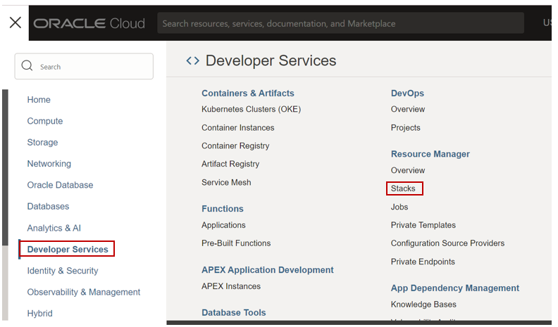

Step 2: Click on Stack and Click on create stack and upload the Budget terraform folder.

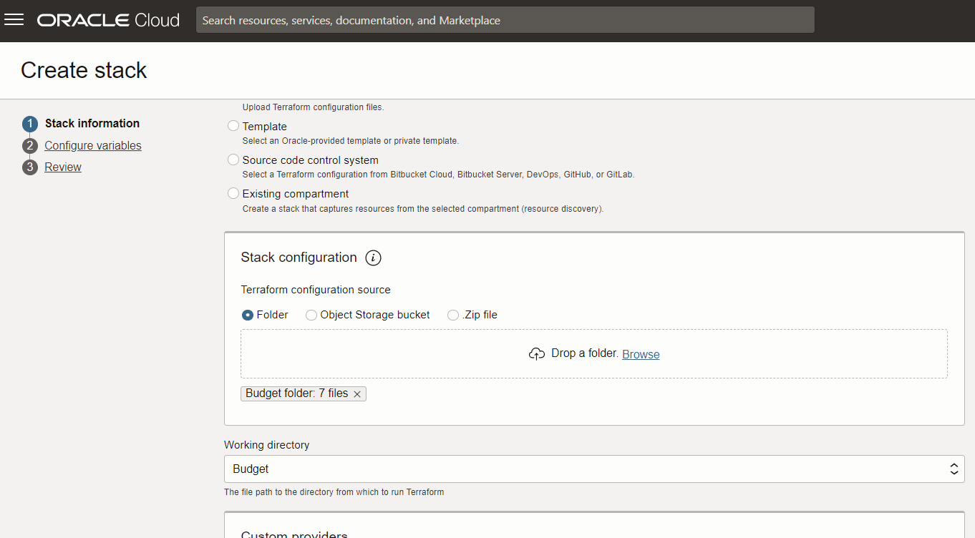

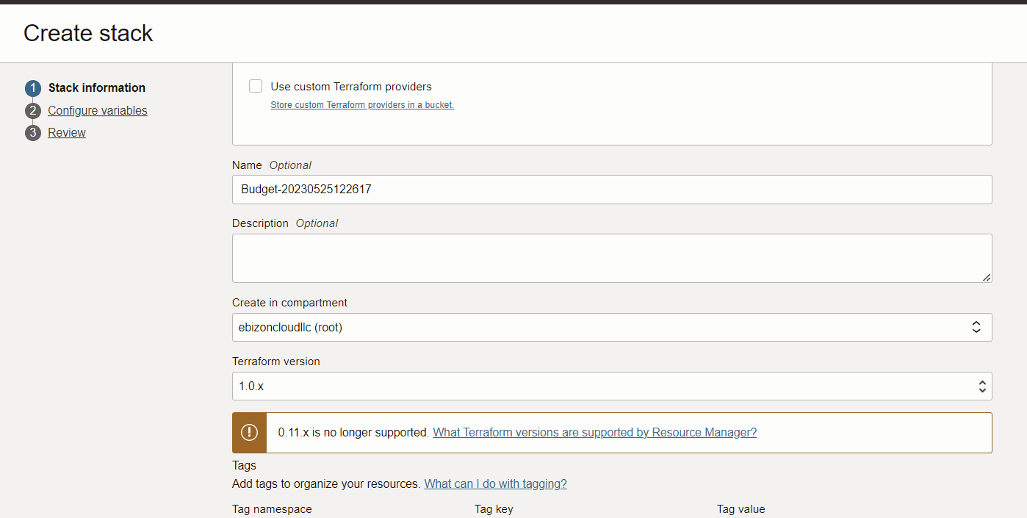

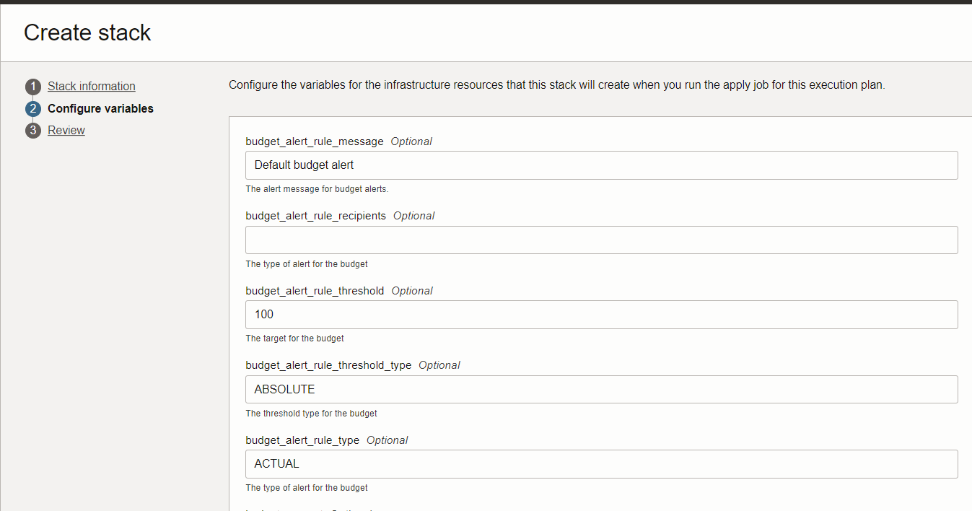

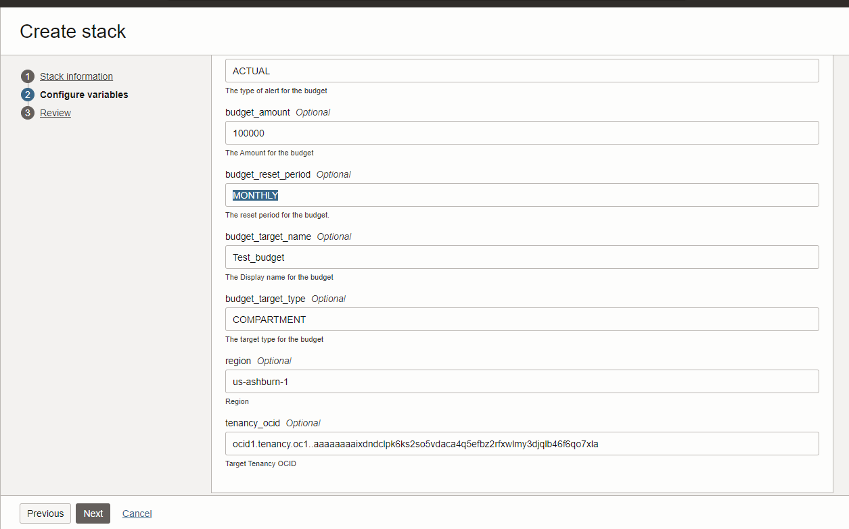

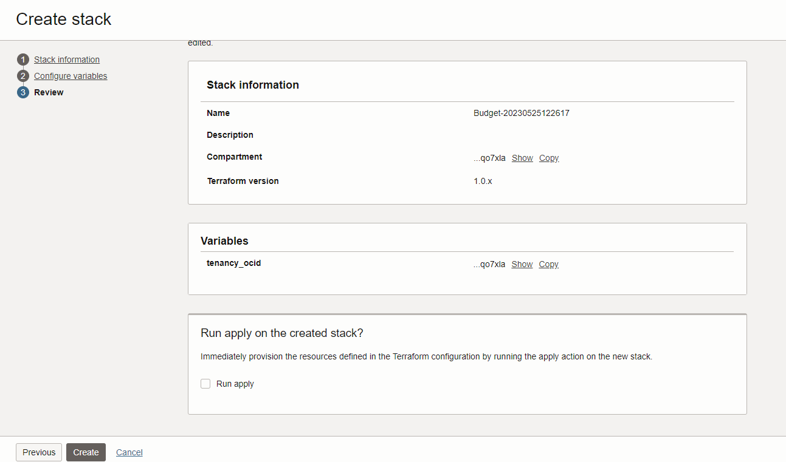

Step 3: Stack detail page click on Plan.

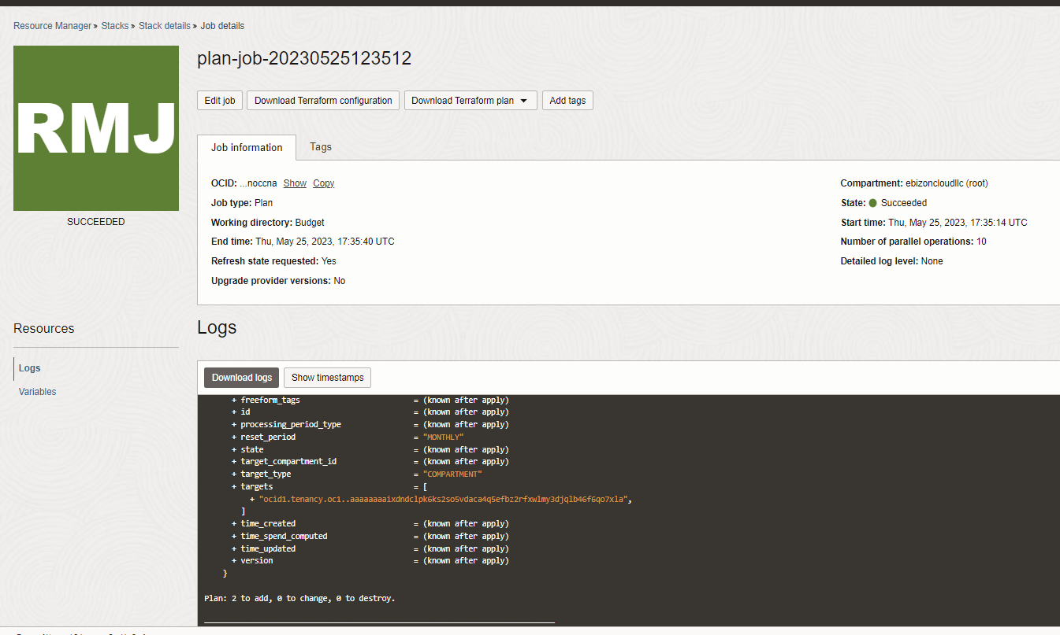

Step 4: Click on Apply

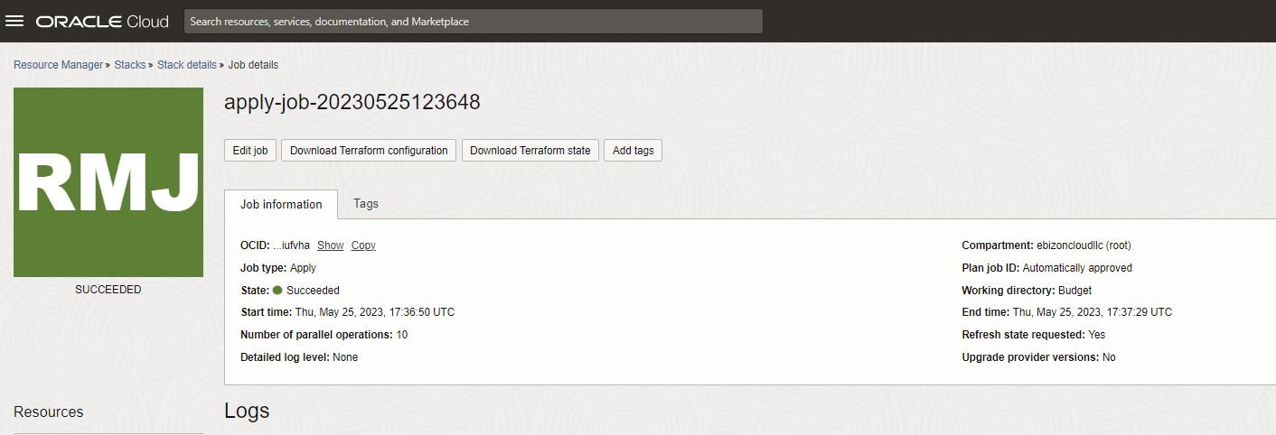
Apply Output
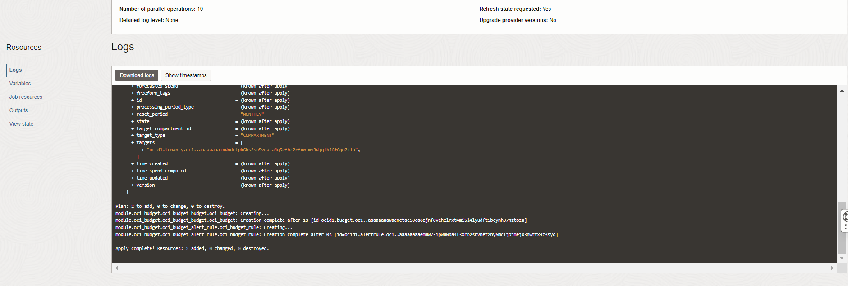

Step 5: Open the navigation menu and click Billing& Cost management next on Budgets.

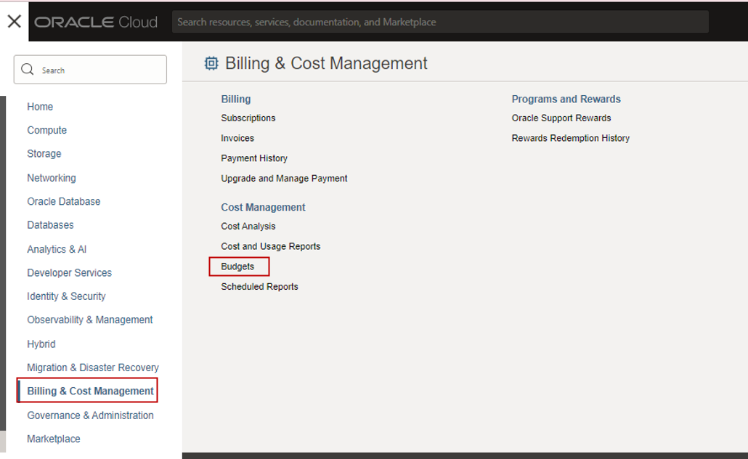
output
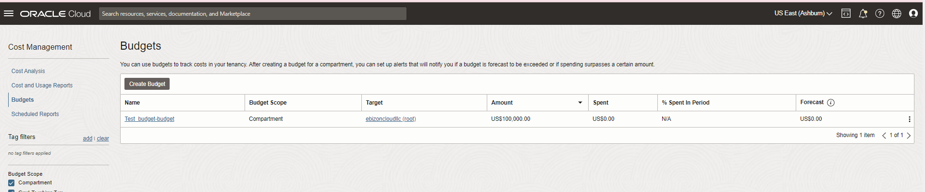
Budget Details page

